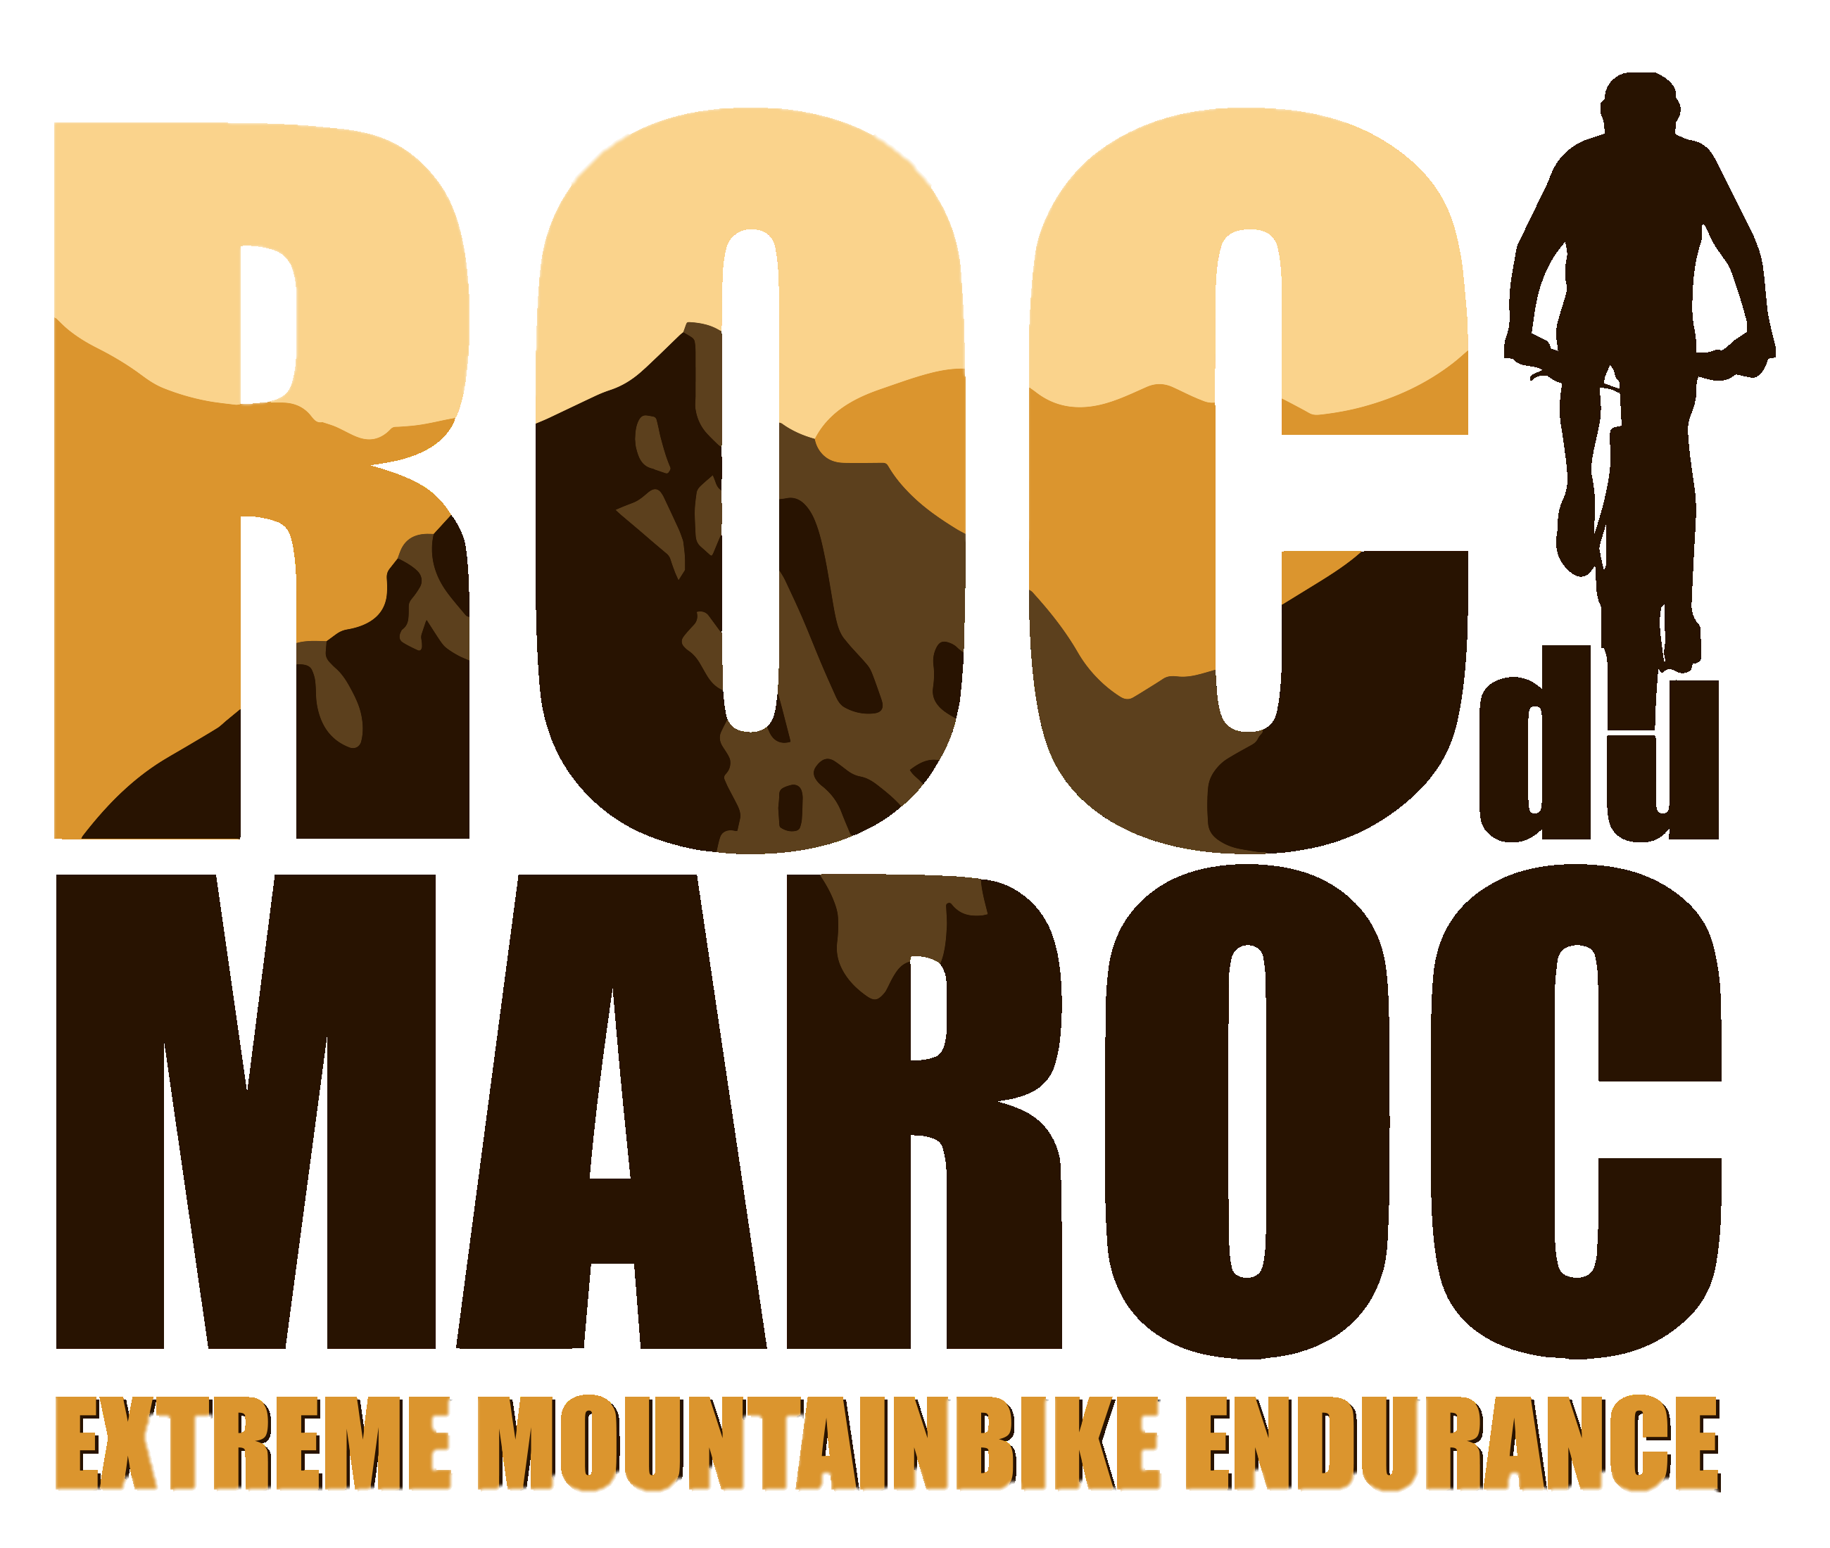

Personal Medical form
(Completely fill in together with your general practitioner or sports physician)

Name: ………………………………………………………………………………………………
First name: ……………………………………………………………………………………………
Date of birth:…………………………………………………………………………………….
Contact person 1: (bvb. wife, parents, children…. name + mobile nr.)

………………………………………………………………………………………….

Contact person 2: (name + mobile nr.) …………………………………………………………………

Doctor: (name & mobile nr.) ………………………………………………………………………………..

Sports doctor :………………………………………………………………………………………………

- Medical history

1.1. Have you already suffered from (or do you suffer from) the following disorders/illnesses?

disorder | Yes/no | Period | specify | treatment
High blood pressure
Diabetes
Lung disease

Heart disaese
Liver disease
Kidney disease
hearing or vision disorder

Epilepsy
others

1.2. Surgical procedures

Have you already undergone major surgical procedures? Yes No
If “yes”, specify, dates
……………………………………………………………………………………………………………………………………………..
……………………………………………………………………………………………………………………………………………..
……………………………………………………………………………………………………………………………………………..

- Allergies:

Are you allergic to (if yes, please specify):

    - Medication: ………………………………………………………………………..

    - nutrition: …………………………………………………………………………..

    - Others: …………………………………………………………………………….

- Varia:

Are you currently taking any medication? (also mention pill use) Yes / No

If “Yes”, please specify: ………………………………
Are you pregnant? yes / No

If “Yes”, please specify ……………………………………………………………..

Do you smoke? yes / No

If “Yes”, please specify how much………………………………………………

How do you estimate your physical condition? (score from 1 to 10) …………………………

4. Clinical research:

Blood pressure, weight, heart and lung auscultation, resting pulse and other relevant clinical findings.
..............................................................................................................................................................................................................................................................................................................................................................................................................................................................................................................................................................................................................................................................................................................................................................................................................................................................................................................................

5. Statement from the general practitioner or sports doctor:

The undersigned, doctor of medicine, declares, after having taken cognizance of all relevant information by the participant-involved with regard to his participation in the RocDuMaroc 2022, that the participant-involved ……………………………………………………... (name and first name) is found to be medically fit to participate in the mountain bike event: RocDuMaroc 2022.

The Participant-involved therefore expressly releases the Organization and its appointee from any contractual and extra-contractual liability as a result of accidents or medical problems that can be associated with the medical certificate signed and stamped by his doctor.

Dr. ………………………………….

………………………………………………………………………….. ( signature )

……………………………………………………………………………(place & date)

